algorithm 1, norm1:

mean train MSE: 6.5033808354400305e-06

mean test MSE: 6.70951755190292e-06

algorithm 1, norm2:

mean train MSE: 7.592498036202682e-05

mean test MSE: 0.0006695996259199744

algorithm 1, mocha:

mean train MSE: 0.0009933184555416903

mean test MSE: 0.06714243806375389

federated learning:

mean train MSE: 4.260032745317739

mean test MSE: 4.3643944748582015

linear regression:

mean train MSE: 4.144765779821399

mean test MSE: 4.223872976925334

decision tree:

mean train MSE: 4.337026613795815

mean test MSE: 4.792970632490308

consensus+innovation:

mean train MSE: 3.0549860678254777

mean test MSE: 3.36565635001498

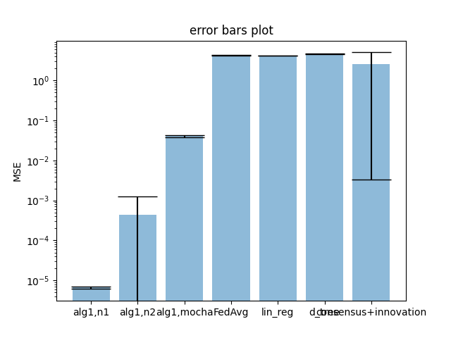

consensus + innovation:

mean total MSE: 2.889822048189604

std_dev total MSE: 2.93543096168903

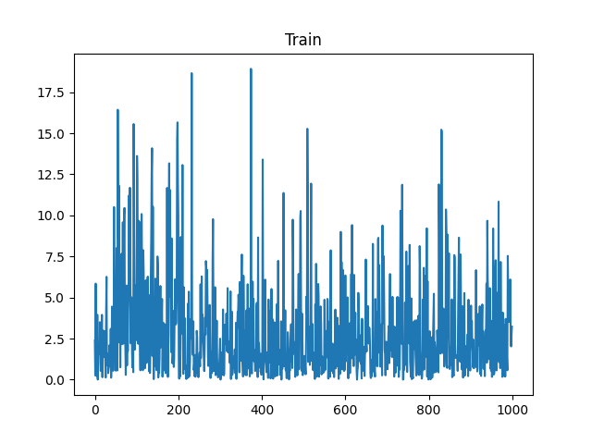  
consensus + innovation:

mean total MSE: 2.5873110796613967

std_dev total MSE: 2.577248237917612

